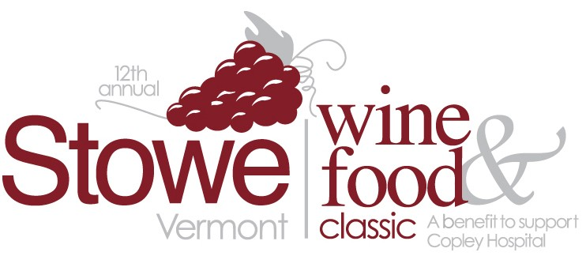
Lot # SUN-1
Table #

Indian Needlecraft Wall Hanging

Handcrafted Artwork from Northern New Dehli, India. Felt, fabric, yarn and paint on burlap depicts rural mountainous scene. 18" high x 34" wide

Retail Value: one of a kind Required Minimum Bid: $150

Auction Bid Number | Amount Bid
Donated by: Friend of Copley Required Bid Increment: $20
Lot # SUN-2
Table #

Gold Purse from Wendy's Closet
Stylish Bold Yellow Hobo Purse with multiple compartments

Retail Value: $79 Required Minimum Bid: $28

Auction Bid Number | Amount Bid
Donated by: Wendy’s Closet Required Bid Increment: $10

Lot # SUN-3
Table #

$50 Gift Certificate to Wendy’s Closet
The secret of every best-dressed woman in Stowe…
Retail Value: $50 Required Minimum Bid: $18

Auction Bid Number | Amount Bid
Donated by: Wendy’s Closet Required Bid Increment: $10

Lot # SUN-4
Table #

Vermont Country Chocolate Gift Basket
MMM….a chocolate sampler from Lake Champlain Chocolates
Retail Value: $55 Required Minimum Bid: $19

Auction Bid Number | Amount Bid
Donated by: Lake Champlain Chocolates Required Bid Increment: $10

Lot # SUN-5
Table #

Keurig Coffee Maker with 22 k-cups
Delicious, fresh coffee one cup at a time….
Retail Value: $125 Required Minimum Bid: $44

Auction Bid Number | Amount Bid
Donated by: Green Mtn Coffee Roasters Required Bid Increment: $20

Lot # SUN-6

Table #

4 Scenic Narrated Cruises with Lake Champlain Shoreline Cruises
Treat yourself and friends to a scenic cruise of Lake Champlain.
Maybe you'll see Champ!
Retail Value: $72 Required Minimum Bid: $25

Auction Bid Number | Amount Bid
Donated by: Lake Champlain Shoreline Cruises Required Bid Increment: $10

Lot # SUN-7

Table #

Boston Park Plaza & Towers Getaway
Beantown Awaits You! See the sights, catch a Red Sox Game and enjoy a touch of the Irish... One Night Stay for 2 at the Boston Park Plaza Hotel & Towers. Includes a $50 gift card to O'Connor's Irish Pub!
Retail Value: $300 Required Minimum Bid: $105
Auction Bid Number | Amount Bid
Donated by: Boston Park Plaza & O’Connor’s Required Bid Increment: $30
Lot # SUN-8

Table #

HoneyBee Soaps Gift Basket
Retail Value: Required Minimum Bid:
Auction Bid Number | Amount Bid
Donated by: HoneyBee Soaps Required Bid Increment:

Lot # SUN-9

Table #

Christmas Tree from Paine's
O Tannenbaum, o Tannenbaum….Christmas Tree - 9' max from Paine's Christmas Trees in Morrisville
Retail Value:$50 Required Minimum Bid: $18
Auction Bid Number | Amount Bid
Donated by: Paine’s Christmas Trees Required Bid Increment: $10

Lot # SUN-10

Table #

Vermont Farm Women – Autographed by Author
Photographer Peter Miller’s “Vermont Farm Women” celebrates the
strength, determination and beauty of the state’s female farmers
Auction Bid Number | Amount Bid
Retail Value: $35 Required Minimum Bid: $12
Donated by: Silver Print Press Required Bid Increment: $10

